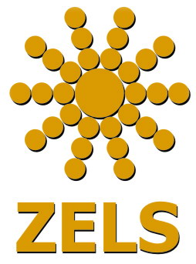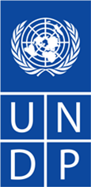

PRESS RELEASE

New Guide for Dispute Resolution in Multicultural Communities Now Available to Citizens, Decision Makers and Community Leaders

Skopje, 12 July 2012: The Association of Local Self Governments (ZELS) and the United Nations Development Programme (UNDP) jointly launched a “Handbook to Support Dispute Resolution in Multicultural Communities”, which will serve as a reference guide to municipal authorities, local civil society organizations, school administrators and other relevant institutions.

“The purpose of this guide is to provide an overview for citizens, local governments and community-based organizations on practices that can be used to resolve disputes in multicultural communities. It also orients readers with local resources that can be called upon to help resolve community-based disputes”, Dusica Perisic from ZELS said.

“Community-based dispute resolution works. Resolving disputes early can help prevent them becoming larger challenges in multi-ethnic communities, UNDP Deputy Resident Representative, Alessandro Fracassetti said. “This is an important resource that lets decisions-makers know to whom to turn, when, and for what types of resources to be able to resolve disputes early in their communities”,

For individuals, who are not professionally engaged in the field of dispute resolution, the vast amount of information on the subject can be complex. This handbook aims to provide an easily accessible starting point for community leaders, who wish to access experts to help mediate disputes. It includes practical information on the different methods for dispute resolution, while including examples of success stories that result from such application.

This handbook was produced in the framework of the United Nations Programme to enhance Inter Ethnic Dialogue and Collaboration, implemented by UNDP, UNICEF and UNESCO, with financial support from the Millennium Development Goals Achievement Fund, funded by the Kingdom of Spain. A contribution was also made by the Swiss Federal Department of Foreign Affairs.

For more information, please contact: Sandra Ismanovski at 070 219 648 or sandra.ismanovski@undp.org

